Agenda
10:30 Call to Order and Regular Business – Emily Nolen and Josh Wells (FDACS)
- Current In-Kind Partner Contributions- Josh Wells
- Reminder: Review SART Partner Contact List for Updates – Emily Nolen
- ICS Recommended Training – Josh Wells
- Upcoming SART Funded Training- Emily Nolen
10:40 SART Partner Spotlight: Humane Society of the United States – Celia Jackson (HSUS)
11:00 Florida Aquaculture Industry Update- Geno Evens (FAA)
11:20 Agriculture Hurricane Loan and Grant Programs – Dr. Savanna Danver (USDA/FSA)
11: 50 2025 SART Planning Conference – LeiAnna Moorhead and team (FDACS)
12:20 SART Partner Updates– All
12:30 Adjourn

Next Virtual SART Partners Meeting: April 23, 2025
Microsoft Teams Meeting
10:00 am – 11:00am

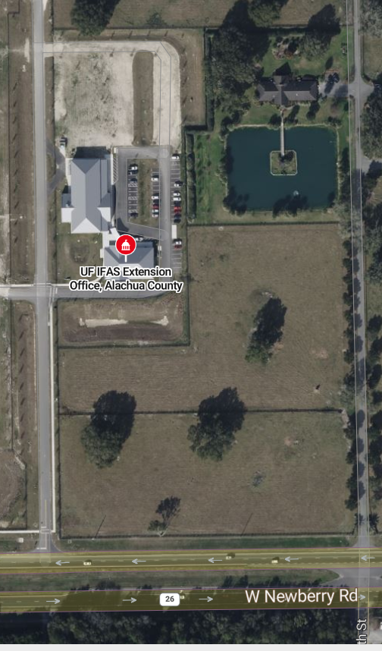

= Parking Available
= Meeting Site
The meeting will be taking place at the Alachua County Institute of Food and Agricultural Services. Parking is available at the star-marked locations. The yellow arrow will be the building where the meeting will be held.

